**WEB TECHNOLOGY PRATICAL FILE**

Submitted By: Vinay Kumar

U.R.N:1905278

C.R.N:1921149

Submitted To: Er. Hanit Kaur

**1.Create a simple web page by writing HTML using a simple text editor, Notepad. Demonstrate the following components of the web page: Page titles and Headings Paragraphs and Inline images**

**Ans:**

<html>

<head>

<title>GNDEC</title>

</head>

<body>

<h1>Department Of Information Technology</h1>

<p>Information technology (IT) is the use of computers to store, retrieve, transmit, and manipulate data[1] or information. IT is typically used within the context of business operations as opposed to personal or entertainment technologies.[2] IT is considered to be a subset of information and communications technology (ICT). An information technology system (IT system) is generally an information system, a communications system, or, more specifically speaking, a computer system – including all hardware, software, and peripheral equipment – operated by a limited group of IT users.</p>

<p>Humans have been storing, retrieving, manipulating, and communicating information since the Sumerians in Mesopotamia developed writing in about 3000 BC.[3] However, the term information technology in its modern sense first appeared in a 1958 article published in the Harvard Business Review; authors Harold J. Leavitt and Thomas L. Whisler commented that "the new technology does not yet have a single established name. We shall call it information technology (IT)." Their definition consists of three categories: techniques for processing, the application of statistical and mathematical methods to decision-making, and the simulation of higher-order thinking through computer programs</p>

<img src="C:\Users\vinay\Downloads\gndec.jpeg" weidth="50%" height="50% ">

</body>

</html>

**Output**

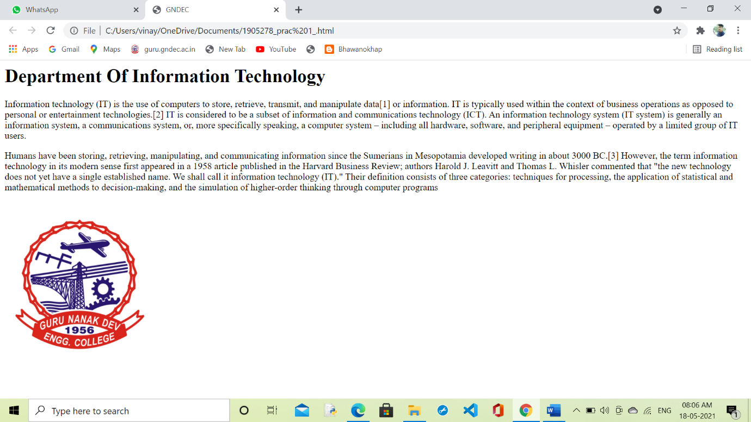

**2. Demonstrate the use of Links, Lists and Tables in HTML. You should be able to link separate pages and create named links within a document, using them to build a “table of contents”.**

**Ans:**

<html>

<head>

<title>Web TEchnology Lab</title>

</head>

<body>

<h1>This is my first program</h1>

<p>Lorem Ipsum is simply dummy text of the printing and typesetting industry. Lorem Ipsum has been the industry's standard dummy text ever since the 1500s, when an unknown printer took a galley of type and scrambled it to make a type specimen book. It has survived not only five centuries, but also the leap into electronic typesetting, remaining essentially unchanged. It was popularised in the 1960s with the release of Letraset sheets containing Lorem Ipsum passages, and more recently with desktop publishing software like Aldus PageMaker including versions of Lorem Ipsum.</p>

<a href="https://www.bhawanokhap.com">This is my personal website</a>

<p>unordered list</p>

<ul>

<li>coffie</li>

<li>tea</li>

<li>snacks</li>

</ul>

<p>ordered list</p>

<ol>

<li>orange</li>

<li>banana</li>

<li>mango</li>

</ol>

<table border="1">

<tr>

<th>Maths</th>

<th>Science</th>

<th>English</th>

<th>Hindi</th>

</tr>

<tr>

<td>60</td>

<td>70</td>

<td>50</td>

<td>70</td>

</tr>

<tr>

<td>78</td>

<td>68</td>

<td>94</td>

<td>77</td>

</tr>

<tr>

<td>98</td>

<td>67</td>

<td>80</td>

<td>70</td>

</tr>

</table>

</body>

</html>

**Output**

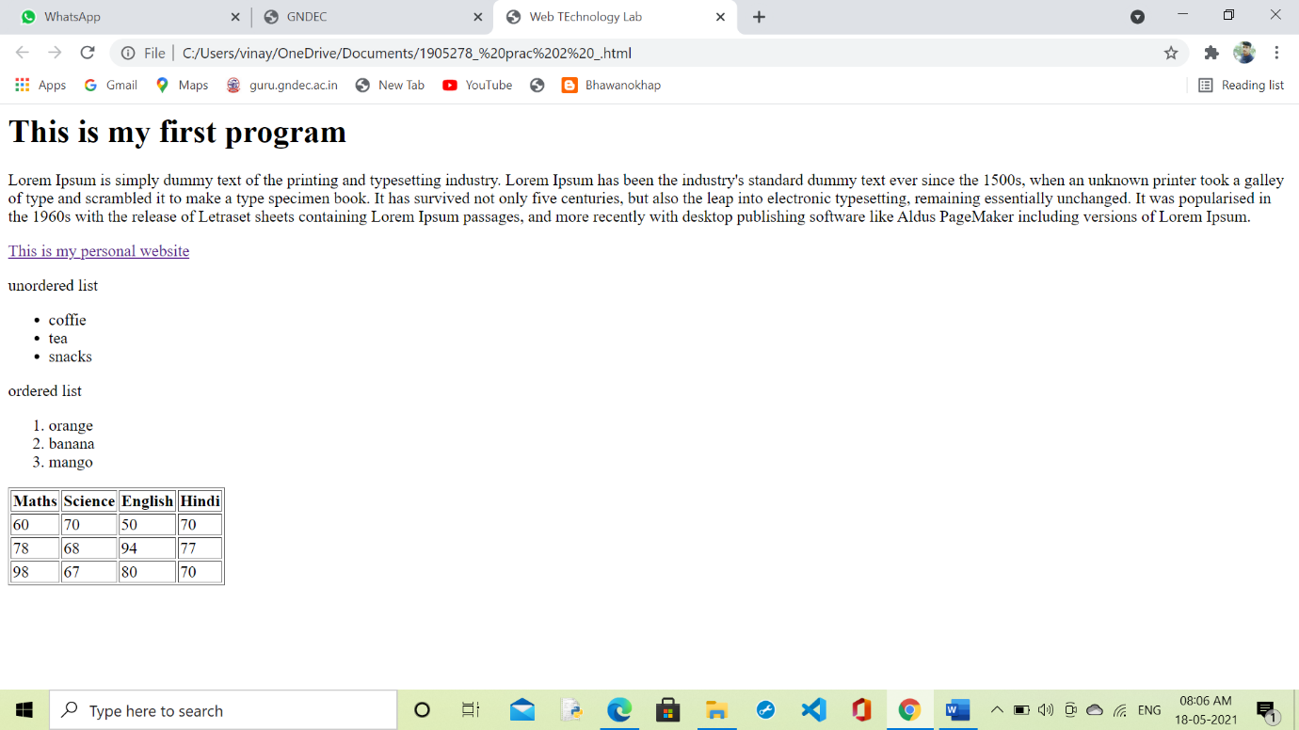

**3. Create simple Forms in HTML and demonstrate the use of various form elements like input box, textarea, submit and radio buttons etc**

**Ans:**

<html>

<head>

<title></title>

</head>

<body>

<h1>Gndec Google Form</h1>

<p><h3>Please Note:</h3> First Name, Last Name, Password and Email are required</p>

<form>

<label for="fn">First Name:</label>

<input type="text" name="First Name" Placeholder="First Name" required>

<label for="ln">Last Name:</label>

<input type="text" name="Last Name" Placeholder="Last Name" required>

<p></p>

<label for="email">Email:</label>

<input type="Email" name="username" Placeholder="name@email.com"required>

<label for="pas">Password:</label>

<input type="Password" name="Password" Placeholder=""required>

<p>Are you over the age of 18?</p>

</form>

<label for="yes">Yes:</label>

<input id="yes"type="radio"name="loc" value="Yes">

<label for="no">No:</label>

<input id="yes"type="radio"name="loc" value="No">

</form>

<h2>Any Other Feedback</h2>

<textarea name="my text" rows="10"cols="100"></textarea>

<p>submit button</p>

<input type="submit" name="" value="Click me">

</body>

</html>

**Output**

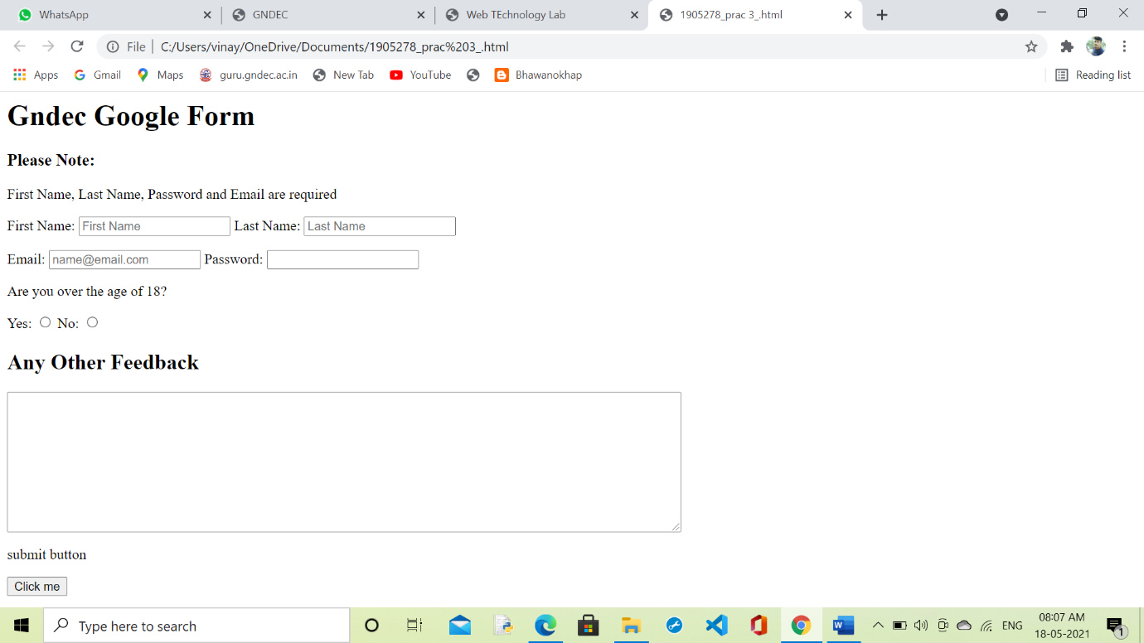

**4. Demonstrate the use of cascading style sheets (CSS) (inline, internal and external) to specify various aspects of style, such as colours and text fonts and sizes, in HTML document.**

**Ans:**

<!DOCTYPE html>

<html>

<head>

<style>

body{background-color: powderblue;

}

h1{color: blue;

}

p{color: red;

font-size:30px;

font-family: "Times New Roman", Times, serif;

}

</style>

</head>

<body>

<h1>INTRODUCTION OF INFORMATION TECHNOLOGY</h1>

<p>Information technology (IT) is the use of computers to store, retrieve, transmit, and manipulate data or information. IT is typically used within the context of business operations as opposed to personal or entertainment technologies. IT is considered to be a subset of information and communications technology (ICT).</p>

</body>

</html>

**Output**

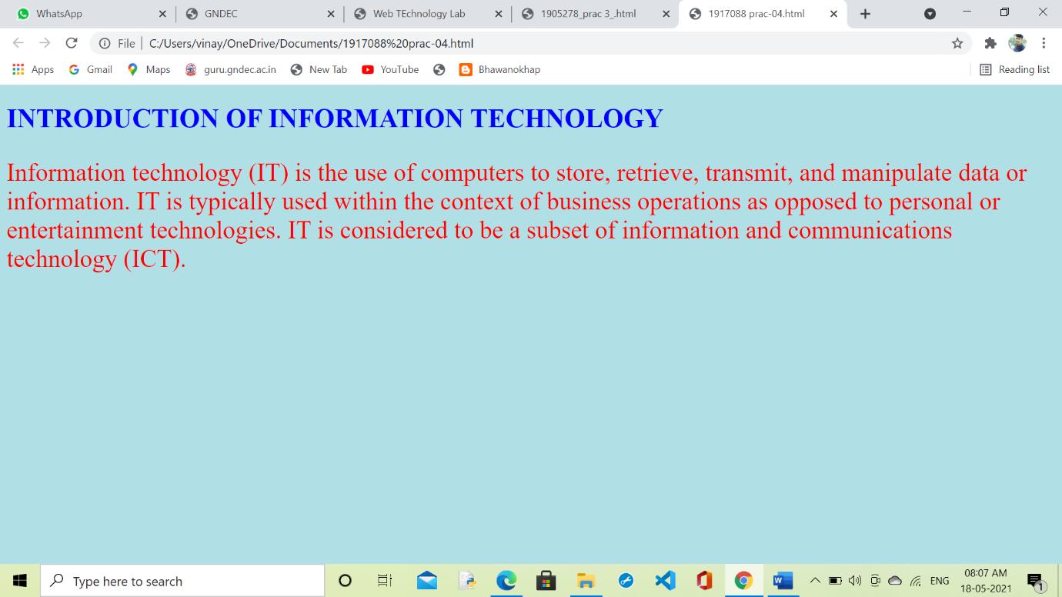

**5. Creation of Web pages using HTML5 and CSS3.**

**Ans:**

<!DOCTYPE html>

<html lang="en">

<head>

<title>CSS Template</title>

<meta charset="utf-8">

<meta name="viewport" content="width=device-width, initial-scale=1">

<style>

* {

box-sizing: border-box;

font-family: Arial, Helvetica, sans-serif;

}

body {

margin: 0;

font-family: Arial, Helvetica, sans-serif;

}

/* Style the top navigation bar */

.topnav {

overflow: hidden;

background-color: #333;

}

/* Style the topnav links */

.topnav a {

float: left;

display: block;

color: #f2f2f2;

text-align: center;

padding: 14px 16px;

text-decoration: none;

}

/* Change color on hover */

.topnav a:hover {

background-color: #ddd;

color: black;

}

/* Style the content */

.content {

background-color: #ddd;

padding: 10px;

height: 200px; /* Should be removed. Only for demonstration */

}

/* Style the footer */

.footer {

background-color: #f1f1f1;

padding: 10px;

}

</style>

</head>

<body>

<div class="topnav">

<a href="#">Link</a>

<a href="#">Link</a>

<a href="#">Link</a>

</div>

<div class="content">

<h2>Welcome to India</h2>

<p>Explore</p>

</div>

<div class="footer">

<p>Footer</p>

</div>

<canvas id="myCanvas" width="200" height="100" style="border:1px solid #d3d3d3;">

Your browser does not support the HTML canvas tag.</canvas>

<script>

var c = document.getElementById("myCanvas");

var ctx = c.getContext("2d");

// Create gradient

var grd = ctx.createLinearGradient(0,0,200,0);

grd.addColorStop(0,"red");

grd.addColorStop(1,"white");

// Fill with gradient

ctx.fillStyle = grd;

ctx.fillRect(10,10,150,80);

</script>

</body>

</html>

**Output**

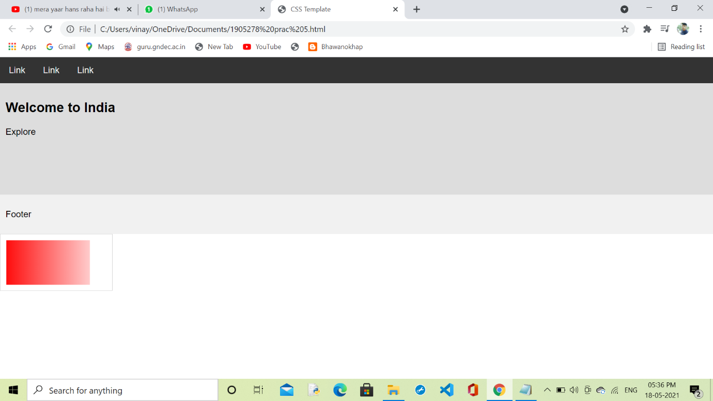

**6. Demonstrate the use of Bootstrap Framework.**

**Ans:**

<!DOCTYPE html>

<html lang="en">

<head>

<meta charset="utf-8">

<meta name="viewport" content="width=device-width, initial-scale=1, shrink-to-fit=no">

<title>Bootstrap 4 Navbar Fixed to Top</title>

<link rel="stylesheet" href="https://stackpath.bootstrapcdn.com/bootstrap/4.5.2/css/bootstrap.min.css">

<link rel="stylesheet" href="https://maxcdn.bootstrapcdn.com/font-awesome/4.7.0/css/font-awesome.min.css">

<script src="https://code.jquery.com/jquery-3.5.1.min.js"></script>

<script src="https://cdn.jsdelivr.net/npm/popper.js@1.16.1/dist/umd/popper.min.js"></script>

<script src="https://stackpath.bootstrapcdn.com/bootstrap/4.5.2/js/bootstrap.min.js"></script>

<style>

.bs-example{

margin: 20px;

}

body{

padding-top: 70px;

}

</style>

</head>

<body>

<div class="bs-example">

<nav class="navbar navbar-expand-md navbar-dark bg-dark fixed-top">

<a href="#" class="navbar-brand">Brand</a>

<button type="button" class="navbar-toggler" data-toggle="collapse" data-target="#navbarCollapse">

<span class="navbar-toggler-icon"></span>

</button>

<div class="collapse navbar-collapse" id="navbarCollapse">

<div class="navbar-nav">

<a href="#" class="nav-item nav-link active">Home</a>

<a href="#" class="nav-item nav-link">Profile</a>

<a href="#" class="nav-item nav-link">Messages</a>

<a href="#" class="nav-item nav-link disabled" tabindex="-1">Reports</a>

</div>

<div class="navbar-nav ml-auto">

<a href="#" class="nav-item nav-link">Login</a>

</div>

</div>

</nav>

<!-- Demo Content -->

<div class="container">

<div class="jumbotron">

<h1>Fixed Top Navbar</h1>

<p class="lead">The fixed-top navbar bar is fixed at the top of the viewport and does not scroll with the rest of the page.</p>

</div>

<p>Lorem ipsum dolor sit amet, consectetur adipiscing elit. Nam eu sem tempor, varius quam at, luctus dui. Mauris magna metus, dapibus nec turpis vel, semper malesuada ante. Vestibulum id metus ac nisl bibendum scelerisque non non purus. Suspendisse varius nibh non aliquet sagittis. In tincidunt orci sit amet elementum vestibulum. Vivamus fermentum in arcu in aliquam. Quisque aliquam porta odio in fringilla. Vivamus nisl leo, blandit at bibendum eu, tristique eget risus. Integer aliquet quam ut elit suscipit, id interdum neque porttitor. Integer faucibus ligula.Quis quam ut magna consequat faucibus. Pellentesque eget nisi a mi suscipit tincidunt. Ut tempus dictum risus. Pellentesque viverra sagittis quam at mattis. Suspendisse potenti. Aliquam sit amet gravida nibh, facilisis gravida odio. Phasellus auctor velit at lacus blandit, commodo iaculis justo viverra. Etiam vitae est arcu. Mauris vel congue dolor. Aliquam eget mi mi. Fusce quam tortor, commodo ac dui quis, bibendum viverra erat. Maecenas mattis lectus enim, quis tincidunt dui molestie euismod. Curabitur et diam tristique, accumsan nunc eu, hendrerit tellus. Tibulum consectetur scelerisque lacus, ac fermentum lorem convallis sed.</p>

<p>Orci facilisis, dignissim tortor vitae, ultrices mi. Vestibulum a iaculis lacus. Phasellus vitae convallis ligula, nec volutpat tellus. Vivamus scelerisque mollis nisl, nec vehicula elit egestas a. Sed luctus metus id mi gravida, faucibus convallis neque pretium. Maecenas quis sapien ut leo fringilla tempor vitae sit amet leo. Donec imperdiet tempus placerat. Pellentesque pulvinar ultrices nunc sed ultrices. Morbi vel mi pretium, fermentum lacus et, viverra tellus. Phasellus sodales libero nec dui convallis, sit amet fermentum sapien auctor. Vestibulum ante ipsum primis in faucibus orci luctus et ultrices posuere cubilia Curae; Sed eu elementum nibh, quis varius libero.Nam eget purus nec est consectetur vehicula. Nullam ultrices nisl risus, in viverra libero egestas sit amet. Etiam porttitor dolor non eros pulvinar malesuada. Vestibulum sit amet est mollis nulla tempus aliquet. Praesent luctus hendrerit arcu non laoreet. Morbi consequat placerat magna, ac ornare odio sagittis sed. Donec vitae ullamcorper purus. Vivamus non metus ac justo porta volutpat.</p>

<p>Pulvinar leo id risus pellentesque vestibulum. Sed diam libero, sodales eget sapien vel, porttitor bibendum enim. Donec sed nibh vitae lorem porttitor blandit in nec ante. Pellentesque vitae metus ipsum. Phasellus sed nunc ac sem malesuada condimentum. Etiam in aliquam lectus. Nam vel sapien diam. Donec pharetra id arcu eget blandit. Proin imperdiet mattis augue in porttitor. Quisque tempus enim id lobortis feugiat. Suspendisse tincidunt risus quis dolor fringilla blandit. Ut sed sapien at purus lacinia porttitor. Nullam iaculis, felis a pretium ornare, dolor nisl semper tortor, vel sagittis lacus est consequat eros. Sed id pretium nisl. Curabitur dolor nisl, laoreet vitae aliquam id.Nullam hendrerit justo non leo aliquet imperdiet. Etiam in sagittis lectus. Suspendisse ultrices placerat accumsan. Mauris quis dapibus orci. In dapibus velit blandit pharetra tincidunt. Quisque non sapien nec lacus condimentum facilisis ut iaculis enim. Sed viverra interdum bibendum. Donec ac sollicitudin dolor. Sed fringilla vitae lacus at rutrum. Phasellus congue vestibulum ligula sed consequat.</p>

<p>Enim arcu, interdum vel metus dignissim, venenatis feugiat purus. Nulla posuere orci ut leo sodales, sed cursus dolor ornare. Cum sociis natoque penatibus et magnis dis parturient montes, nascetur ridiculus mus. Etiam sit amet quam orci. Nulla sollicitudin lectus eget posuere venenatis. Sed vestibulum elementum sagittis. Quisque tristique tortor quis feugiat sollicitudin. Ut pellentesque luctus vulputate. Ut at odio ac erat blandit vehicula ut eget urna. In hac habitasse platea dictumst. Nullam ut iaculis nibh, eget eleifend elit.Convallis eget pretium eu, bibendum non leo. Proin suscipit purus adipiscing dolor gravida, in fermentum sapien blandit. Praesent pellentesque ligula dui, in gravida turpis vehicula ac. Pellentesque hendrerit nunc ut luctus hendrerit. Aliquam nec tincidunt urna. Ut interdum nec odio non interdum. Curabitur ligula justo, dapibus non ligula tristique, dapibus tristique nulla. Aliquam pulvinar dapibus eros, rutrum pretium urna iaculis ut. Nam est est, tempus id egestas et, viverra in dui. Aliquam gravida orci tortor, sed congue justo ornare vel. Cras in quam consectetur eros varius scelerisque. Ut vel fermentum purus. Nullam interdum blandit turpis, id pellentesque massa feugiat at. Ut sed lectus lectus. Vestibulum ante ipsum primis in faucibus orci luctus et ultrices posuere cubilia Curae; Nulla rutrum, ante quis convallis ultricies, magna quam rhoncus erat, in lacinia libero magna a ipsum.</p>

<p>Fusce enim arcu, interdum vel metus dignissim, venenatis feugiat purus. Nulla posuere orci ut leo sodales, sed cursus dolor ornare. Cum sociis natoque penatibus et magnis dis parturient montes, nascetur ridiculus mus. Etiam sit amet quam orci. Nulla sollicitudin lectus eget posuere venenatis. Sed vestibulum elementum sagittis. Quisque tristique tortor quis feugiat sollicitudin. Ut pellentesque luctus vulputate. Ut at odio ac erat blandit vehicula ut eget urna. In hac habitasse platea dictumst. Nullam ut iaculis nibh, eget eleifend elit.</p>

</div>

</div>

</body>

</html>

**Output**

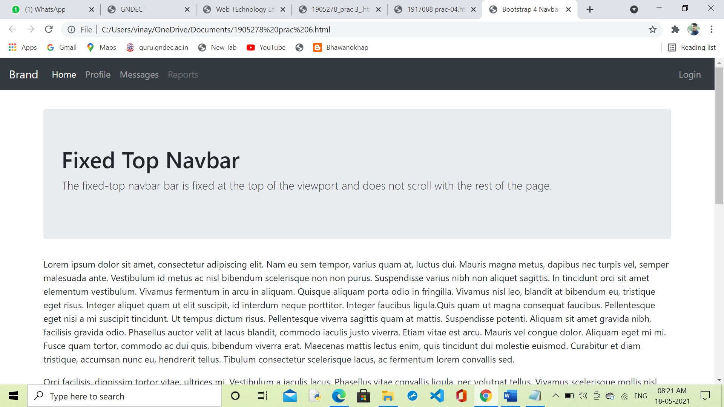

**7. Creating web pages using PHP.**

**Ans:**

<!DOCTYPE HTML>

<html>

<head>

<style>

.error {color: #FF0000;}

</style>

</head>

<body>

<?php

// define variables and set to empty values

$nameErr = $emailErr = $genderErr = $websiteErr = "";

$name = $email = $gender = $comment = $website = "";

if ($_SERVER["REQUEST_METHOD"] == "POST") {

if (empty($_POST["name"])) {

$nameErr = "Name is required";

} else {

$name = test_input($_POST["name"]);

// check if name only contains letters and whitespace

if (!preg_match("/^[a-zA-Z-' ]*$/",$name)) {

$nameErr = "Only letters and white space allowed";

}

}

if (empty($_POST["email"])) {

$emailErr = "Email is required";

} else {

$email = test_input($_POST["email"]);

// check if e-mail address is well-formed

if (!filter_var($email, FILTER_VALIDATE_EMAIL)) {

$emailErr = "Invalid email format";

}

}

if (empty($_POST["website"])) {

$website = "";

} else {

$website = test_input($_POST["website"]);

// check if URL address syntax is valid

if (!preg_match("/\b(?:(?:https?|ftp):\/\/|www\.)[-a-z0-9+&@#\/%?=_|!:,.;]*[-a-z0-9+&@#\/%=_|]/i",$website)) {

$websiteErr = "Invalid URL";

}

}

if (empty($_POST["comment"])) {

$comment = "";

} else {

$comment = test_input($_POST["comment"]);

}

if (empty($_POST["gender"])) {

$genderErr = "Gender is required";

} else {

$gender = test_input($_POST["gender"]);

}

}

function test_input($data) {

$data = trim($data);

$data = stripslashes($data);

$data = htmlspecialchars($data);

return $data;

}

?>

<h2>PHP Form Validation Example</h2>

<p><span class="error">* required field</span></p>

<form method="post" action="<?php echo htmlspecialchars($_SERVER["PHP_SELF"]);?>">

Name: <input type="text" name="name">

<span class="error">* <?php echo $nameErr;?></span>

<br><br>

E-mail: <input type="text" name="email">

<span class="error">* <?php echo $emailErr;?></span>

<br><br>

Website: <input type="text" name="website">

<span class="error"><?php echo $websiteErr;?></span>

<br><br>

Comment: <textarea name="comment" rows="5" cols="40"></textarea>

<br><br>

Gender:

<input type="radio" name="gender" value="female">Female

<input type="radio" name="gender" value="male">Male

<input type="radio" name="gender" value="other">Other

<span class="error">* <?php echo $genderErr;?></span>

<br><br>

<input type="submit" name="submit" value="Submit">

</form>

<?php

echo "<h2>Your Input:</h2>";

echo $name;

echo "<br>";

echo $email;

echo "<br>";

echo $website;

echo "<br>";

echo $comment;

echo "<br>";

echo $gender;

?>

</body>

</html>

**output**

